Image | 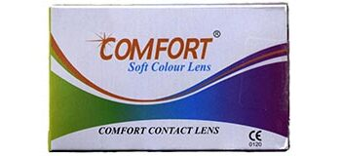
Brand | DIOR
Model Name | COMFORT
Price | RS 4100
PRODUCT DETAILS

